Ras (G13A)
Catalog Number: CR-M26191
Gene Symbol: H-Ras; K-Ras; N-Ras
Description: Anti-HRAS (G13A) Mouse Monoclonal Antibody

Background: Belongs to the small GTPase superfamily. Ras family binds GDP/GTP and possess intrinsic GTPase activity, alternate between an inactive form bound to GDP and an active form bound to GTP. Activated by a guanine nucleotide-exchange factor (GEF) and inactivated by a GTPase-activating protein (GAP).Located in cell membrane, lipid-anchor, cytoplasmic side and Golgi apparatus membrane.
Immunogen: A synthetic peptide from the internal region of HRas which includes the mutation of G13A, human origin.
Tested applications: ELISA, WB, IHC
Recommended dilutions:
ELISA: 1:1000-1:5000
WB: 1:500-1:1000
IHC: 1:50-1:100
Concentration: 1 mg/ml
Host: Mouse
Clonality: Monoclonal
Purity: Purified from ascites
Format: Liquid
Storage buffer:
Preservative: no
Constituents: PBS (without Mg²⁺ and Ca²⁺), pH 7.4, 150 mM NaCl, 50% glycerol
Species Reactivity: Recognizes G13A mutant, but not wild-type H-RAS of vertebrates.
Storage Conditions: Store at -20°C. Avoid
freeze / thaw cycles.

Western blot:
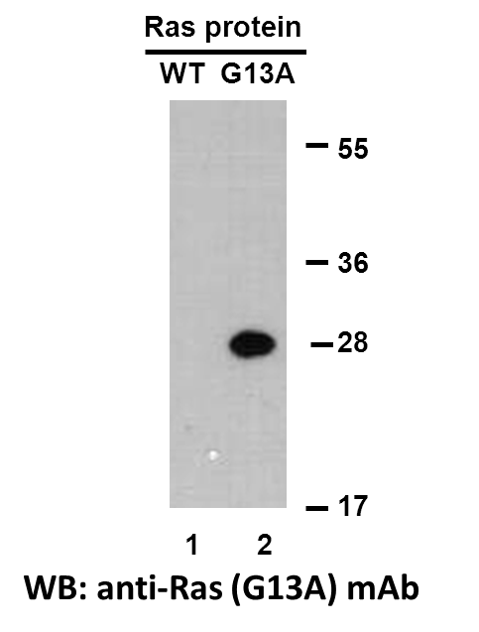
Western blot analysis of recombinant HRas (G13A) and wildtype proteins. Purified His-tagged HRas (G13A) protein (lane 2) and corresponding wildtype protein (lane 1) were blotted with anti-HRas (G13A) monoclonal antibody (Cat. #26191).

Immunofluorescence:
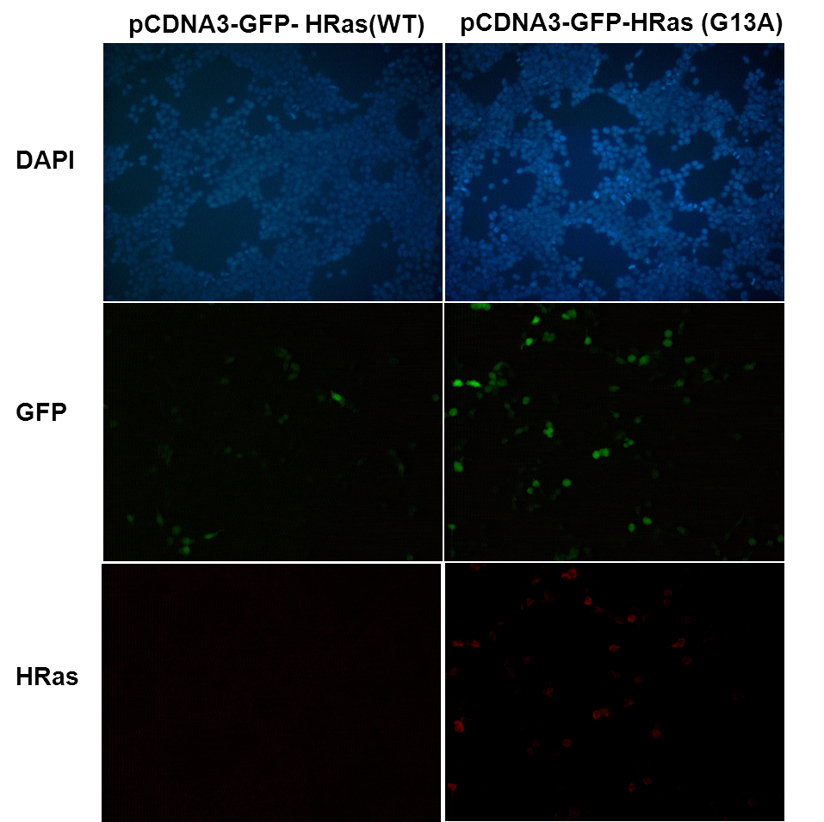
Immunofluorescence of cells expressing Ras proteins with anti-HRas (G13A) antibody. HEK293T cells were transfected with pCDNA3-GFP-HRas (WT) plasmid (left column) or pCDNA3-GFP-HRas (G13A) plasmid (right column), then fixed and stained with anti-HRas (G13A) monoclonal antibody (Cat. #26191).

科博瑞（武汉）生物科技有限公司
TEL：027-87615885 15972062685
- mail：3636901710@qq.com
Web:www.coburybio.com

